**VISVESVARAYA TECHNOLOGICAL UNIVERSITY**

**“JnanaSangama”, Belgaum -590014, Karnataka.**



**LAB REPORT**

**on**

**OPERATING SYSTEMS**

***Submitted by***

**Aditya Dinesh Netrakar (1BM22CS017)**

***in partial fulfillment for the award of the degree of***

**BACHELOR OF ENGINEERING**

***in***

**COMPUTER SCIENCE AND ENGINEERING**



**B.M.S. COLLEGE OF ENGINEERING**

**(Autonomous Institution under VTU)**

**BENGALURU-560019**

**Apr-2024 to Aug-2024**

**B. M. S. College of Engineering,**

**Bull Temple Road, Bangalore 560019**

(Affiliated To Visvesvaraya Technological University, Belgaum)

**Department of Computer Science and Engineering**



**CERTIFICATE**

This is to certify that the Lab work entitled “OPERATING SYSTEMS – 23CS4PCOPS” carried out by **Aditya Dinesh Netrakar(1BM22CS017),** who is bonafide student of **B. M. S. College of Engineering.** It is in partial fulfillment for the award of **Bachelor of Engineering in Computer Science and Engineering** of the Visvesvaraya Technological University, Belgaum during the year 2024. The Lab report has been approved as it satisfies the academic requirements in respect of a **OPERATING SYSTEMS - (23CS4PCOPS)** work prescribed for the said degree.

Rashmi Bagalkot                **Dr. Jyothi S Nayak**

Assistant Professor Professor and Head

Department of CSE Department of CSE

BMSCE, Bengaluru BMSCE, Bengaluru

**Index Sheet**

|  |  |  |
| --- | --- | --- |
| **Sl. No.** | **Experiment Title** | **Page No.** |
| 1. | FCFS AND SJF | 1-8 |
| 2. | PRIORITY AND ROUND ROBIN | 9-20 |
| 3. | RATE-MONOTONIC AND EARLIEST DEADLINE FIRST | 21-29 |
| 4. | PRODUCER-CONSUMER PROBLEM | 30-33 |
| 5. | DINERS-PHILOSOPHERS PROBLEM | 34-38 |
| 6. | BANKERS ALGORITHM(DEADLOCK AVOIDANCE) | 39-42 |
| 7. | DEADLOCK DETECTION | 43-47 |
| 8. | CONTIGIOUS MEMORY ALLOCATION(FIRST, BEST, WORST FIT) | 48-54 |
| 9. | PAGE REPLACEMENT(FIFO, LRU, OPTIMAL) | 55-62 |
| 10. | DISK SCHEDULLING ALGORITHM | 63-71 |

**Program -1**

**Write a C program to simulate the following non-pre-emptive CPU scheduling algorithm to find turnaround time and waiting time.**

**FCFS**

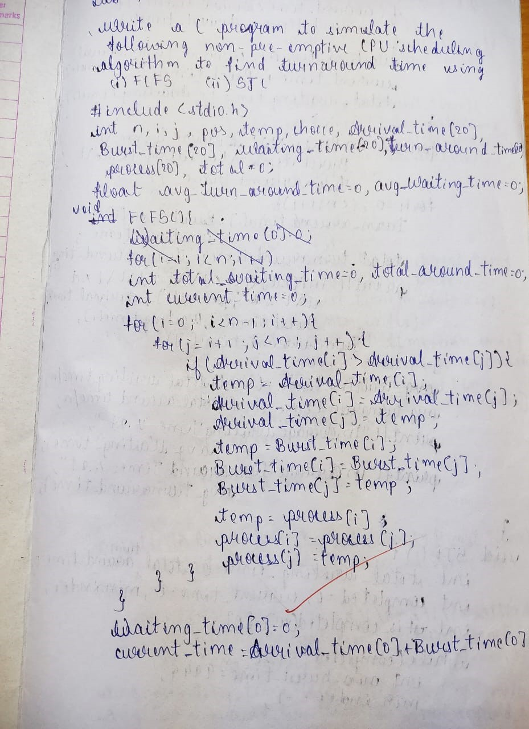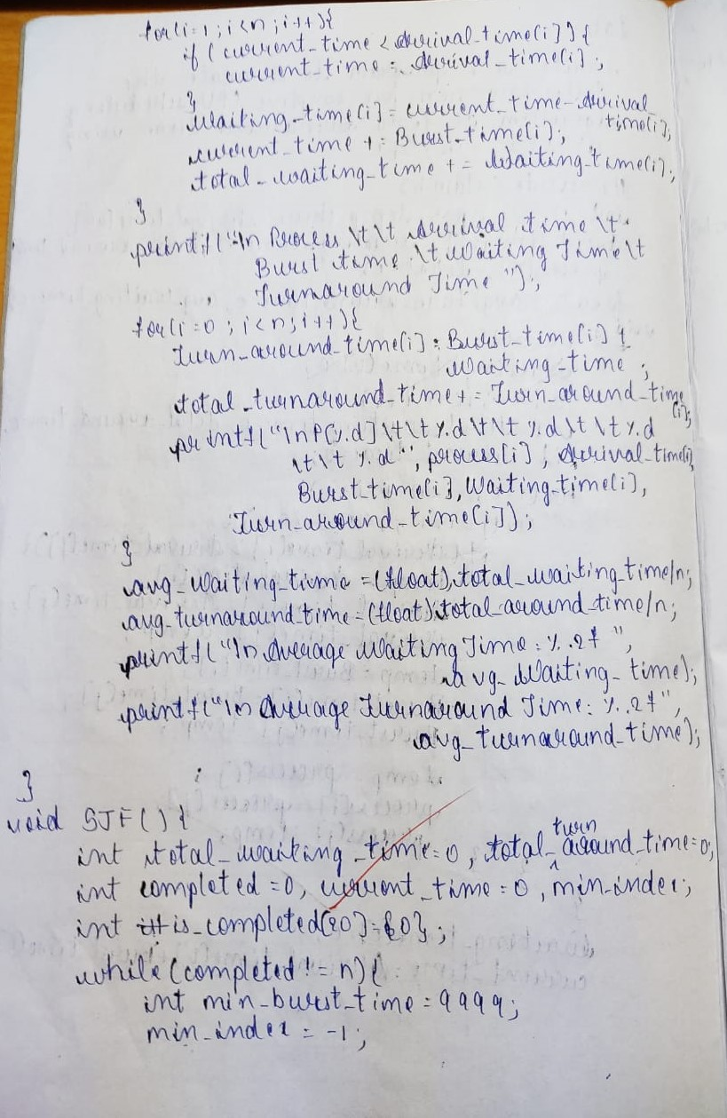

**Output**

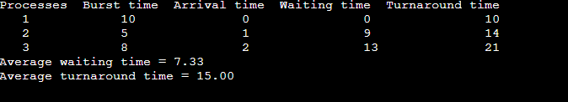

**SJF (pre-emptive)**

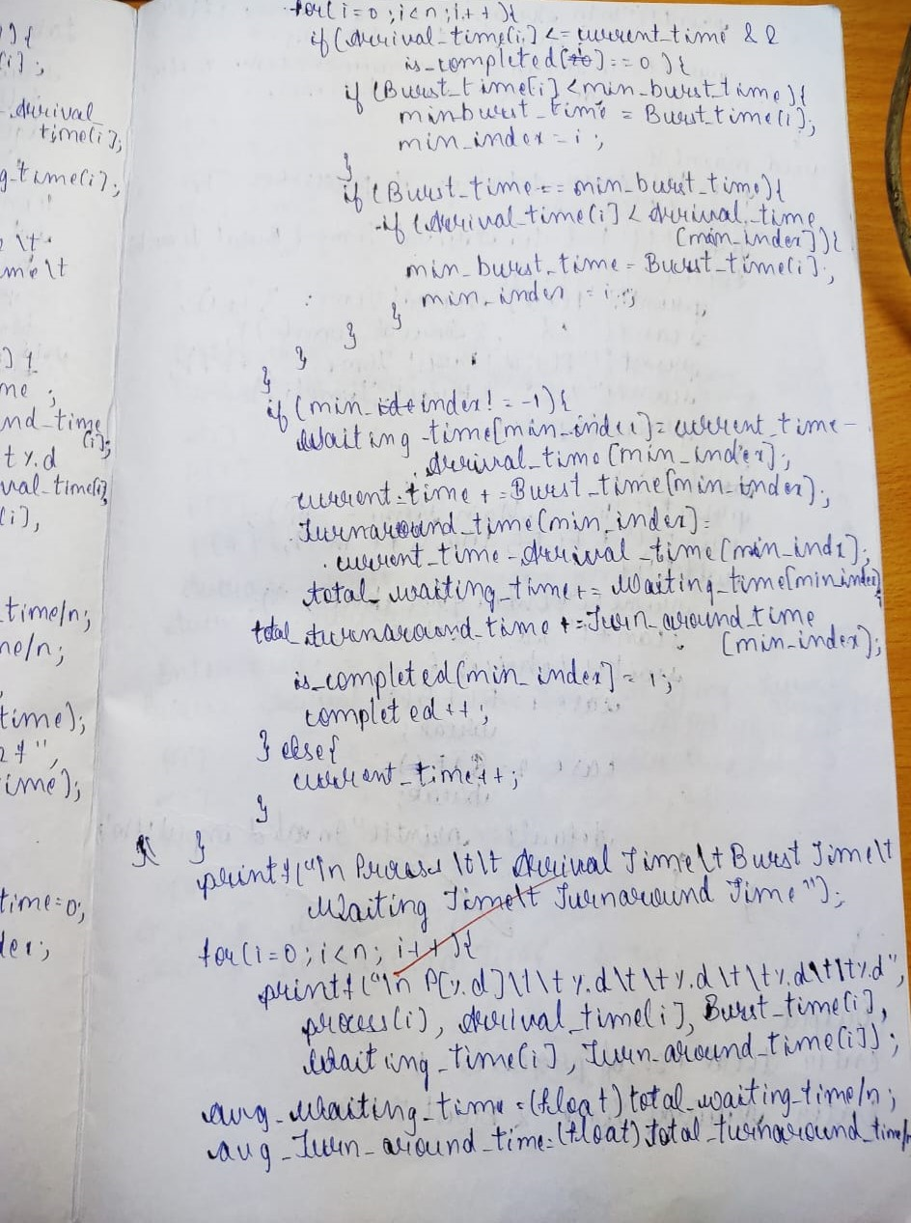

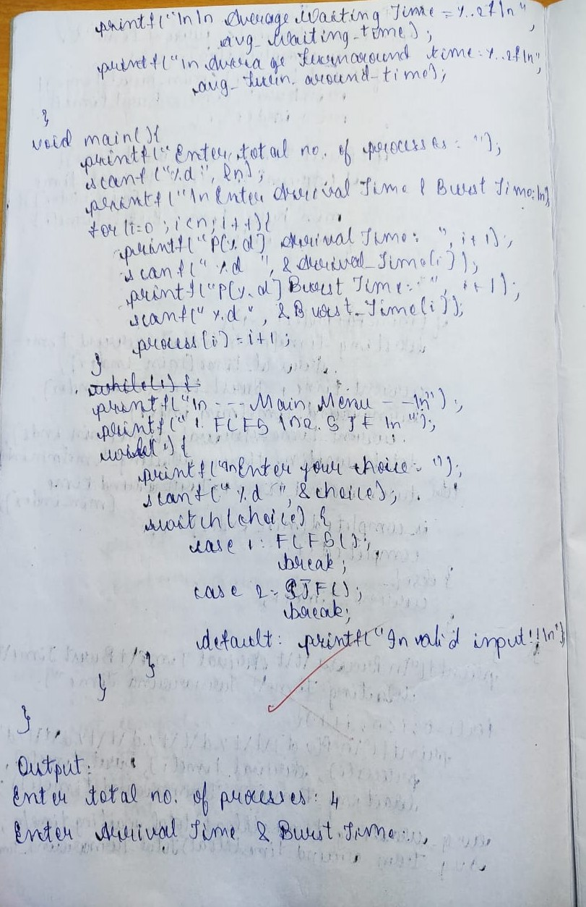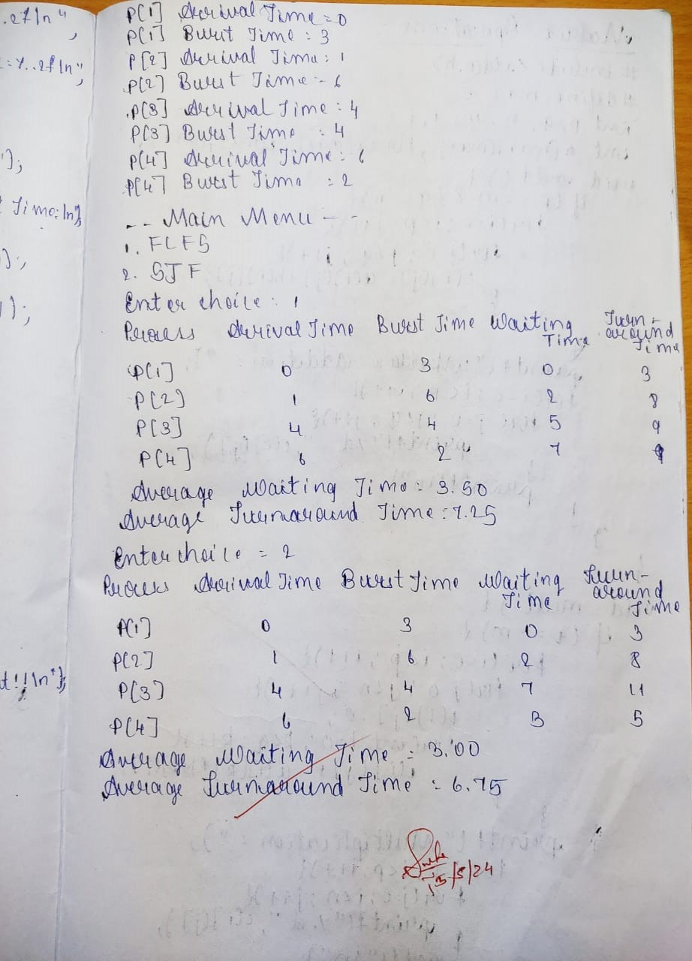

**OUTPUT**

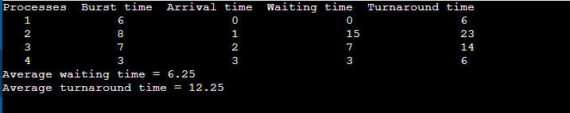

**Program-2**

**Write a C program to simulate the following CPU scheduling to find turnaround time and waiting time.**

**Priority (pre-emptive)**

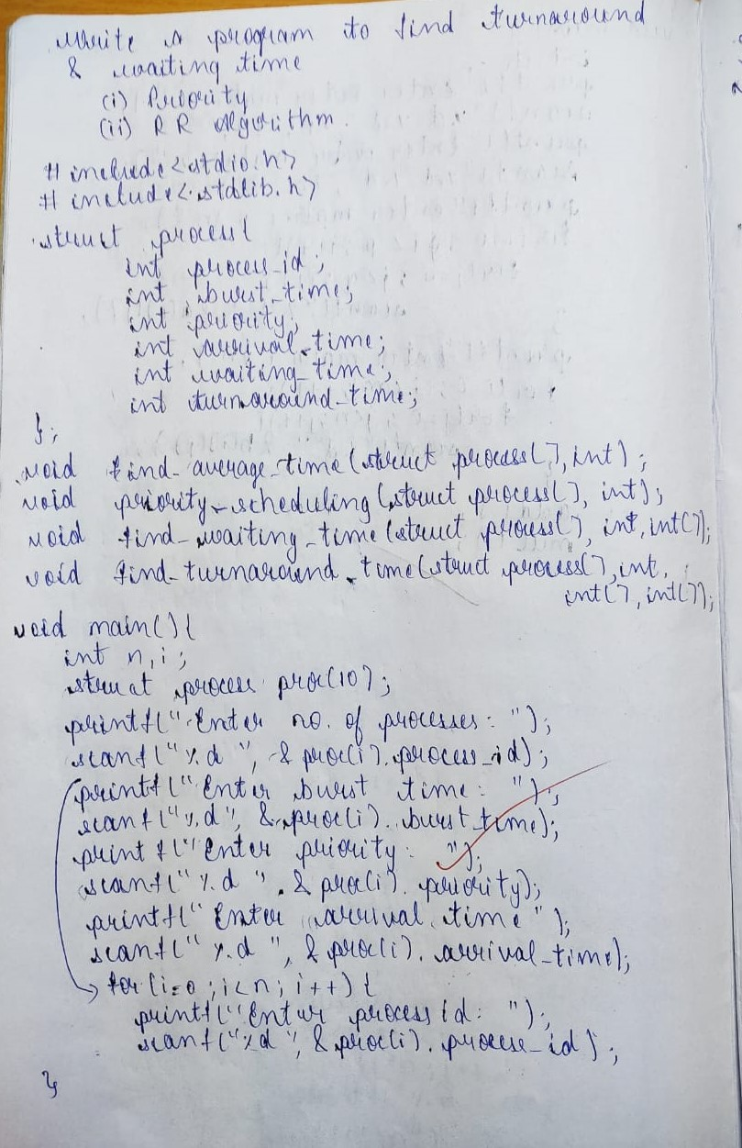

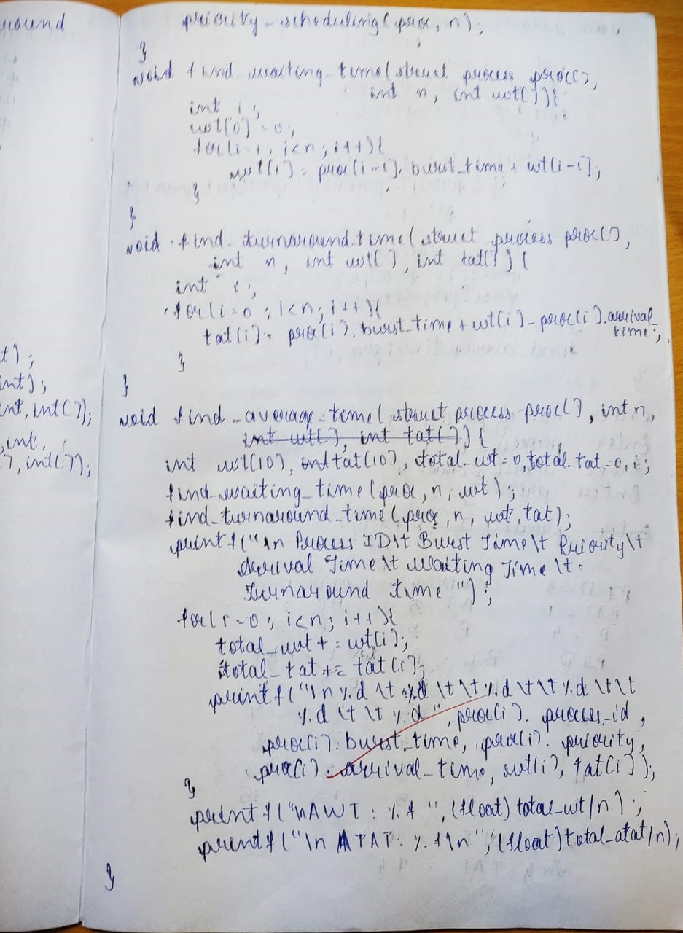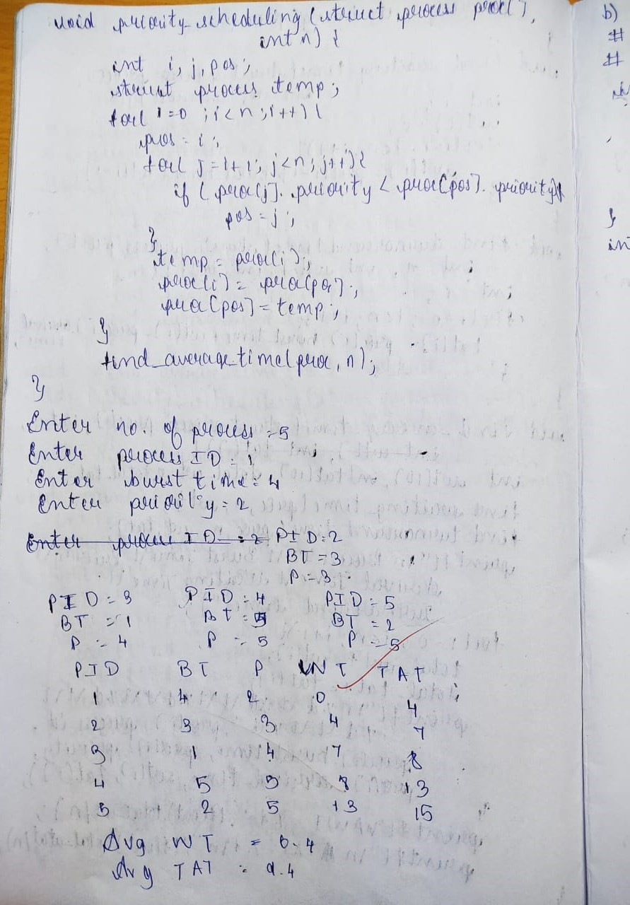

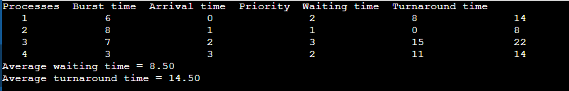

**Round Robin (Experiment with different quantum sizes for RR algorithm)**

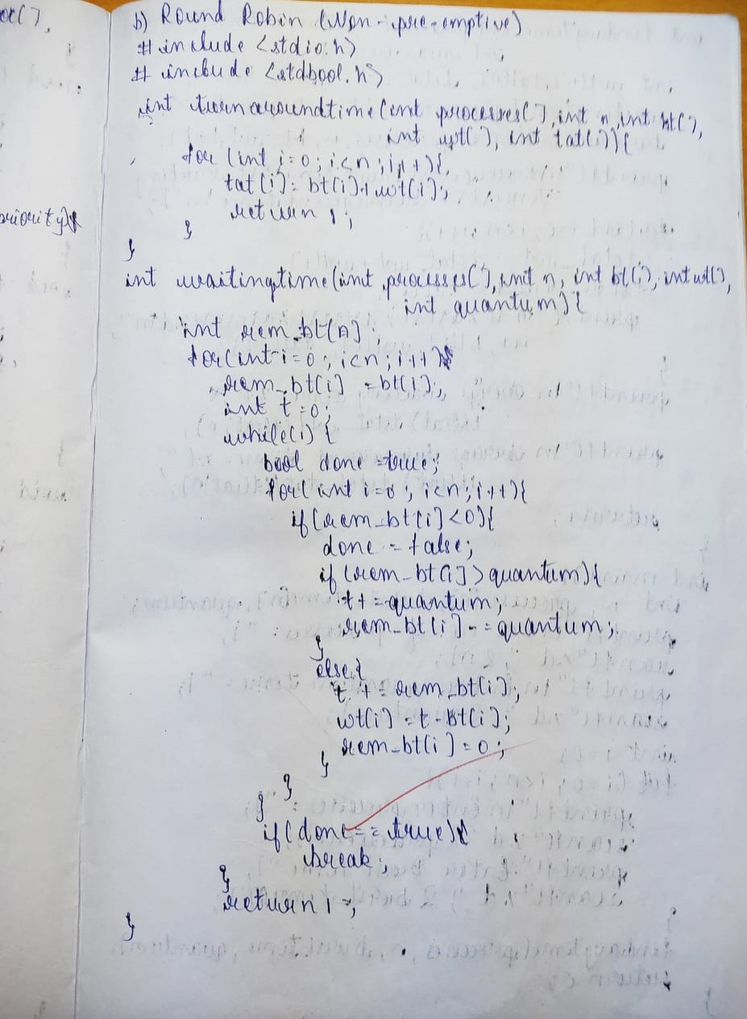

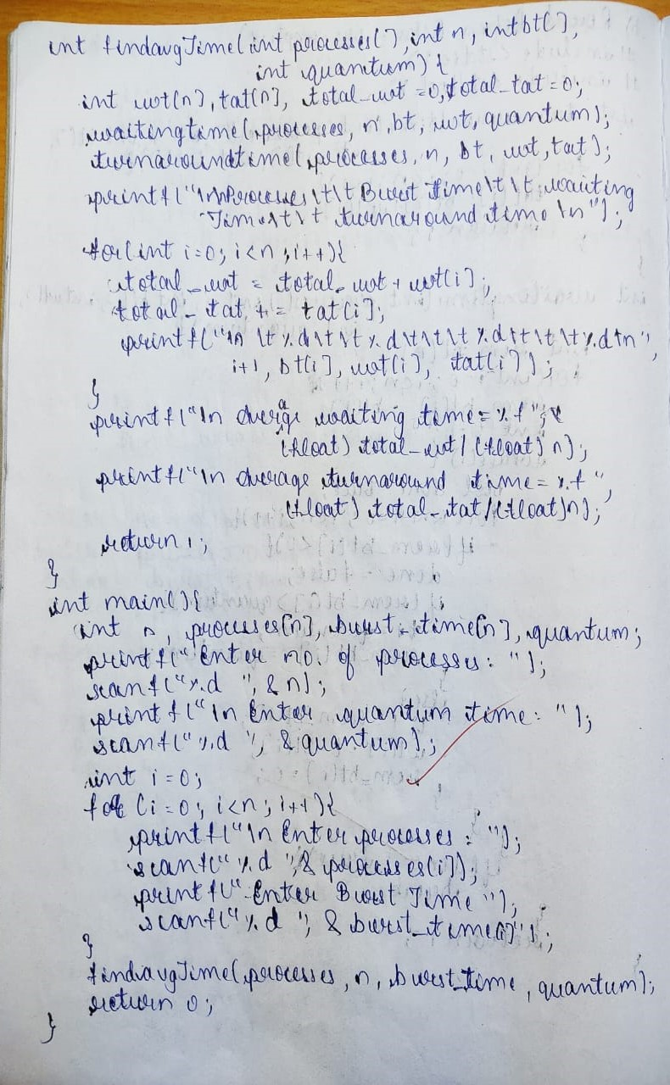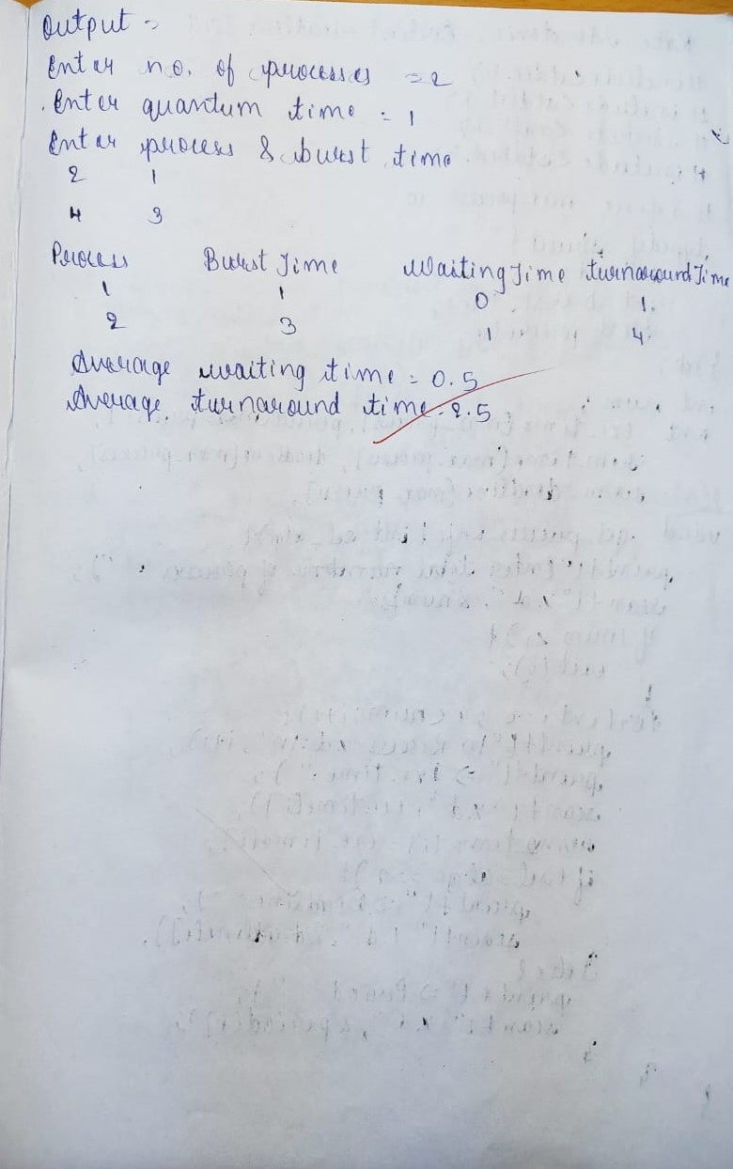

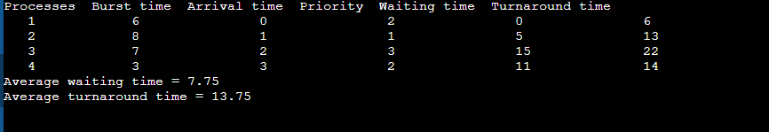

**Program 4**

**Write a C program to simulate Real-Time CPU Scheduling algorithms:**

**Rate- Monotonic**

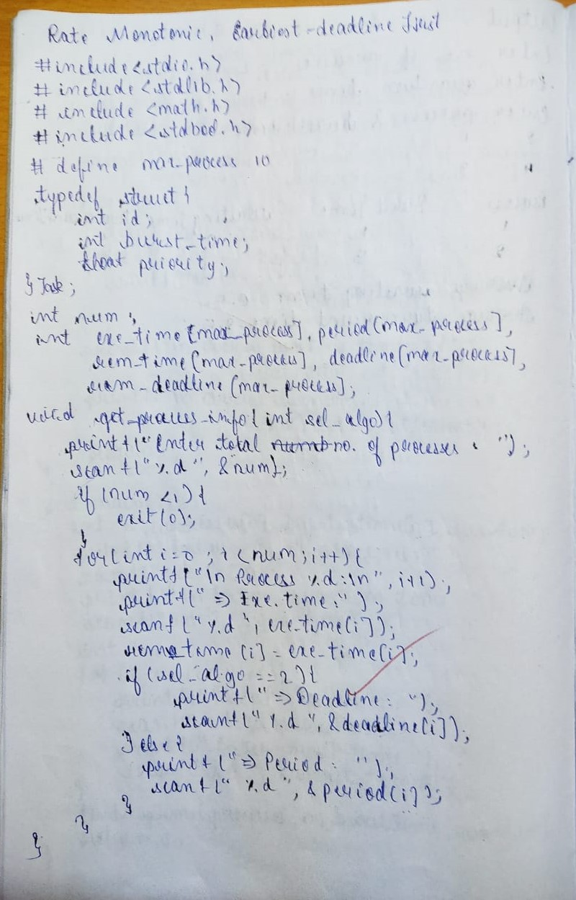

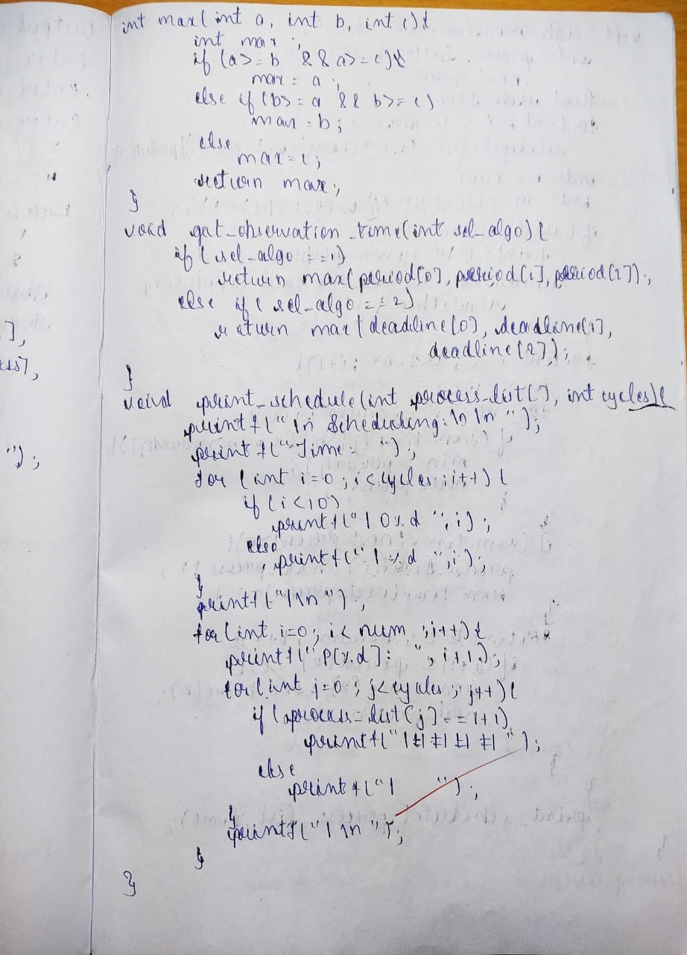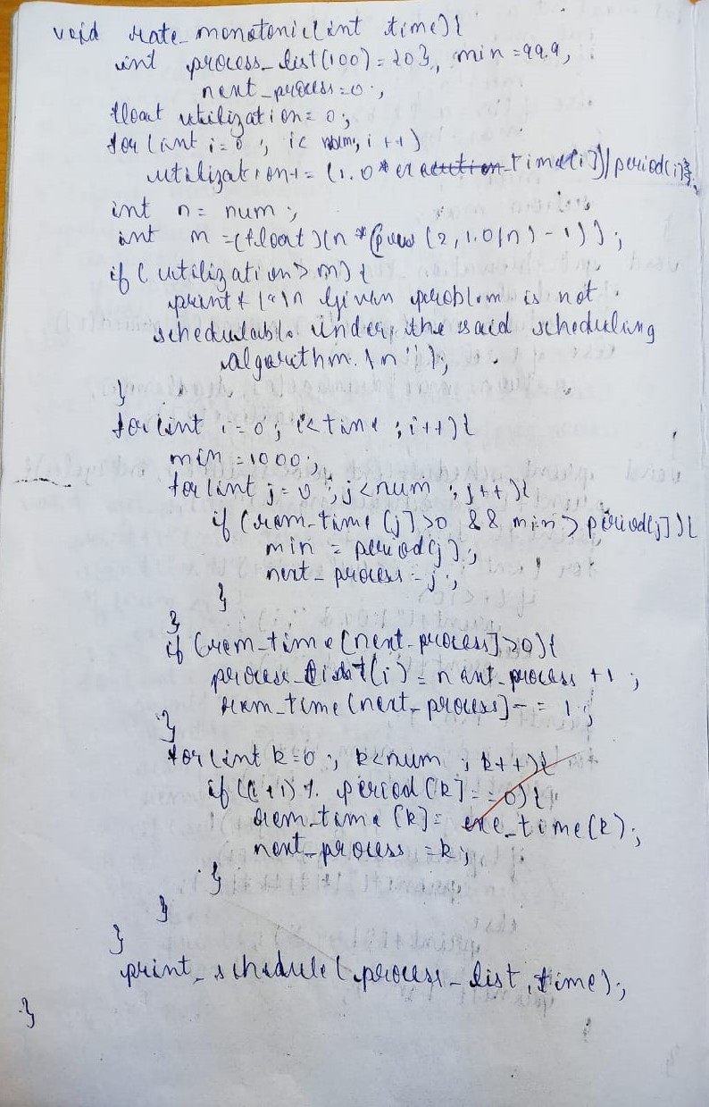

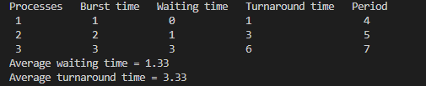

**Earliest-deadline First**

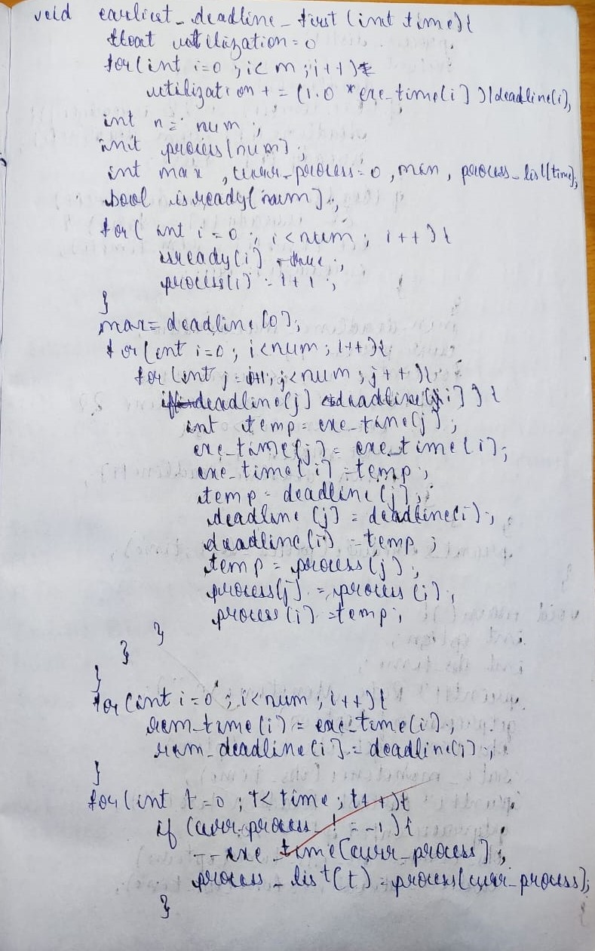

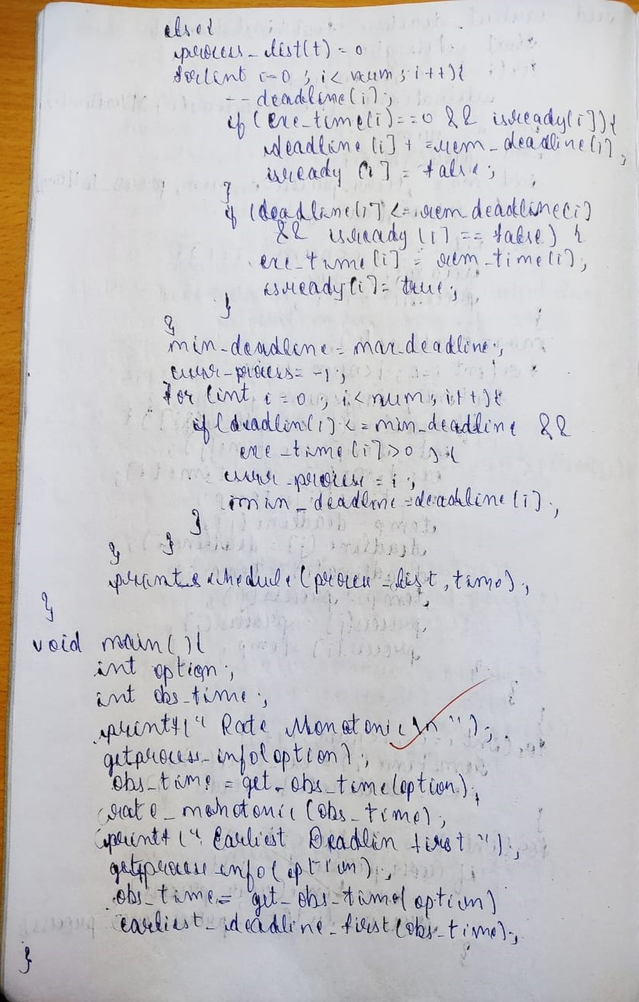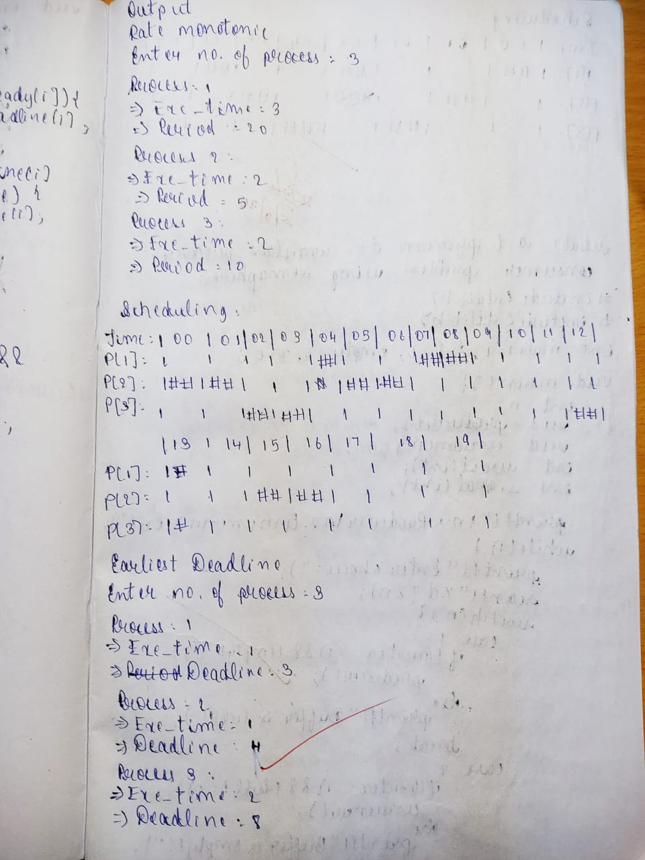

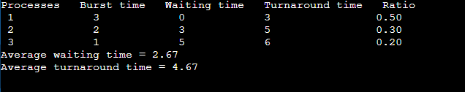

**Program 5**

**Write a C program to simulate producer-consumer problem using semaphores.**

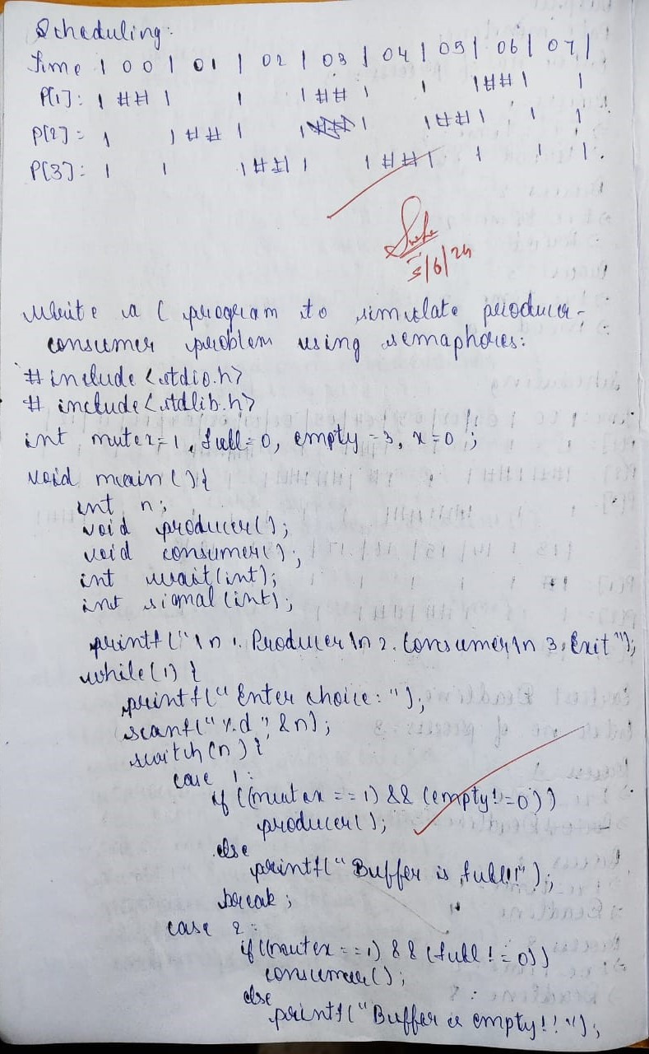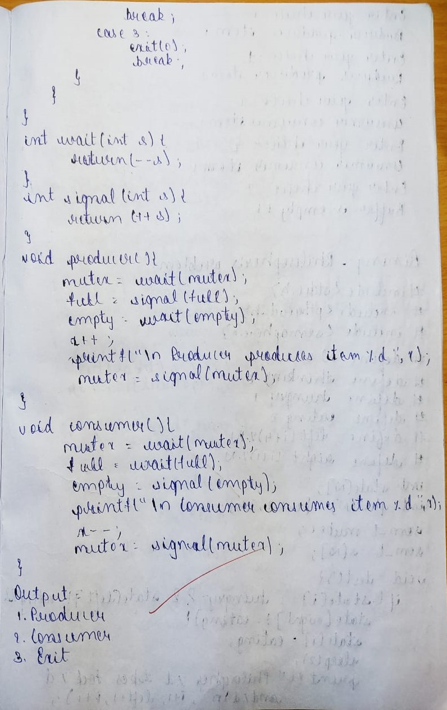

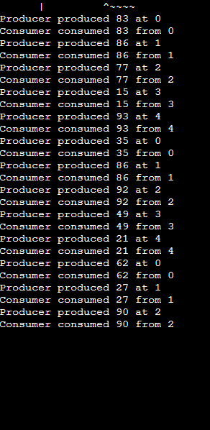

**Program 6**

**Write a C program to simulate the concept of Dining-Philosophers problem.**

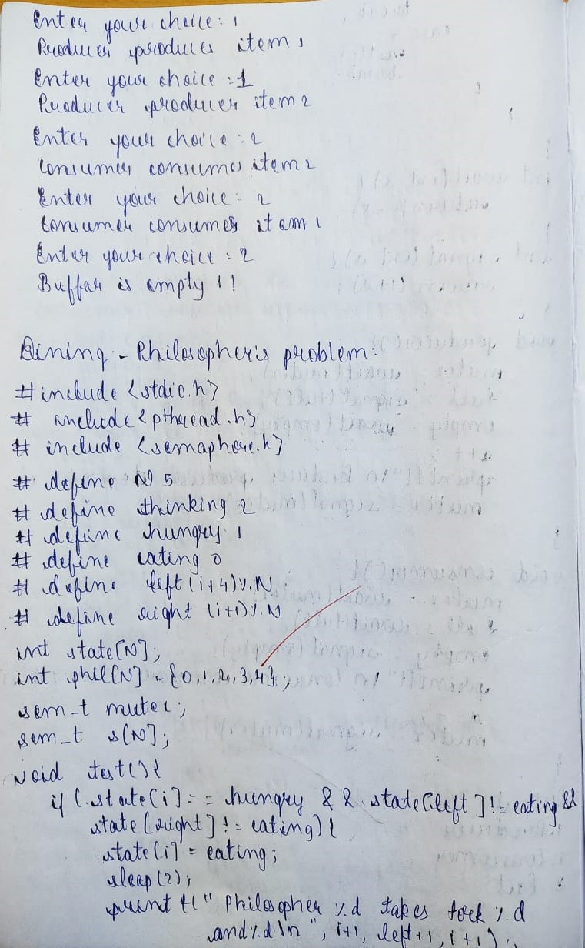

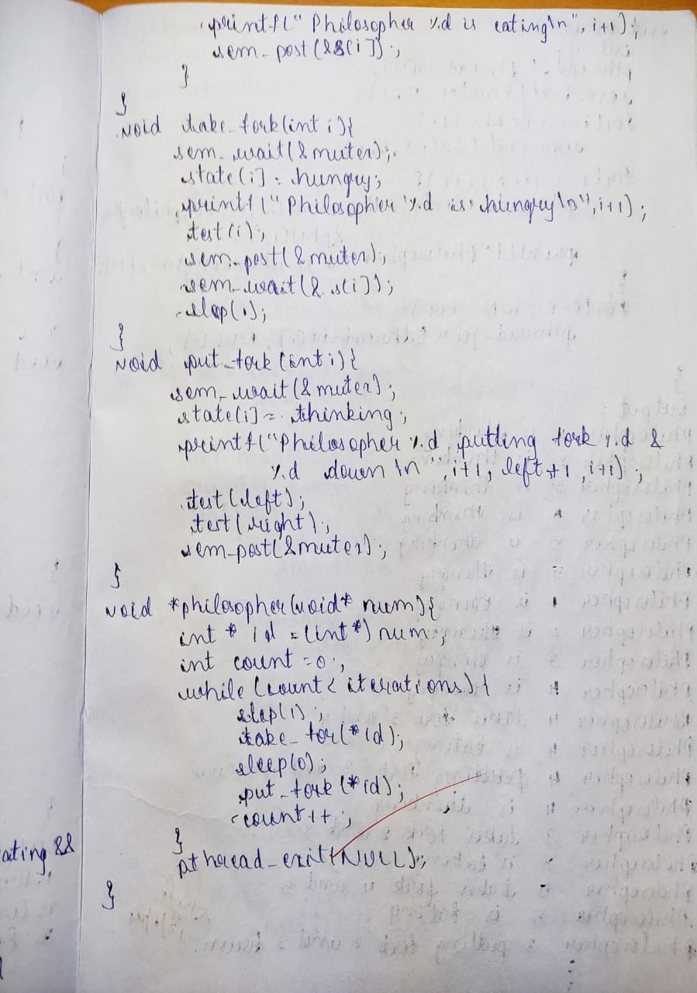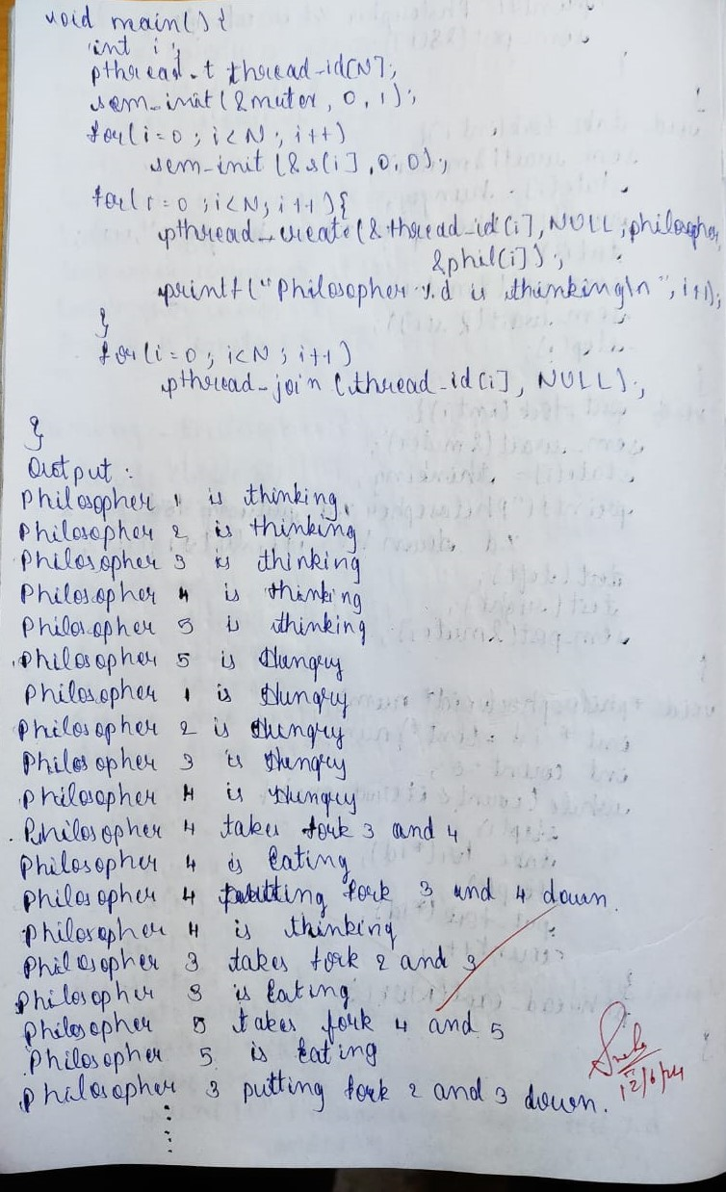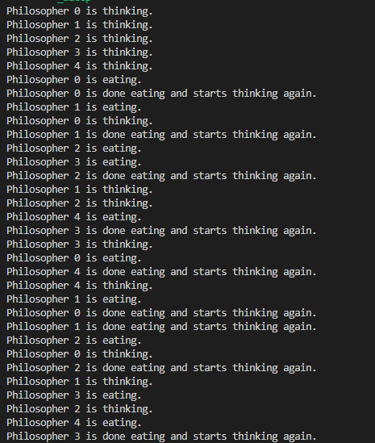

**Program 7**

**Write a C program to simulate Bankers algorithm for the purpose of deadlock avoidance.**

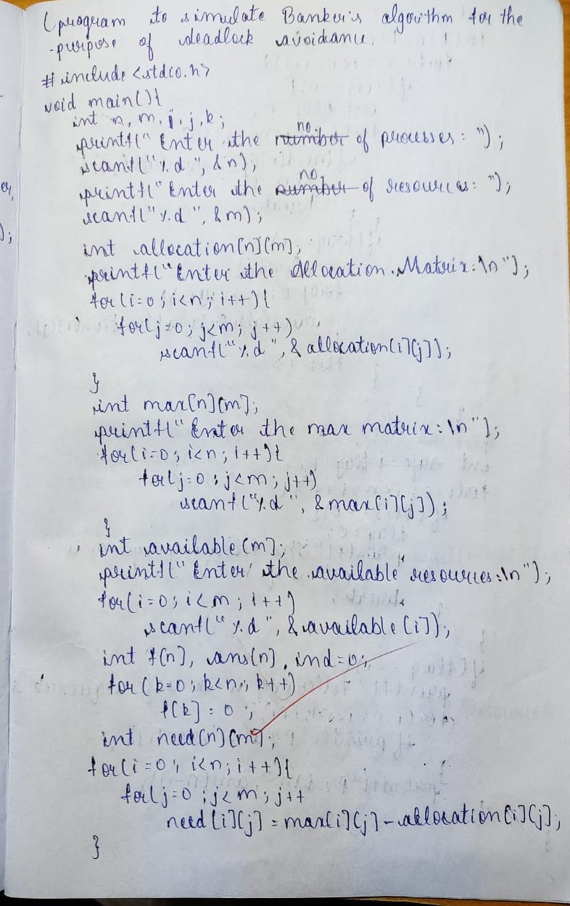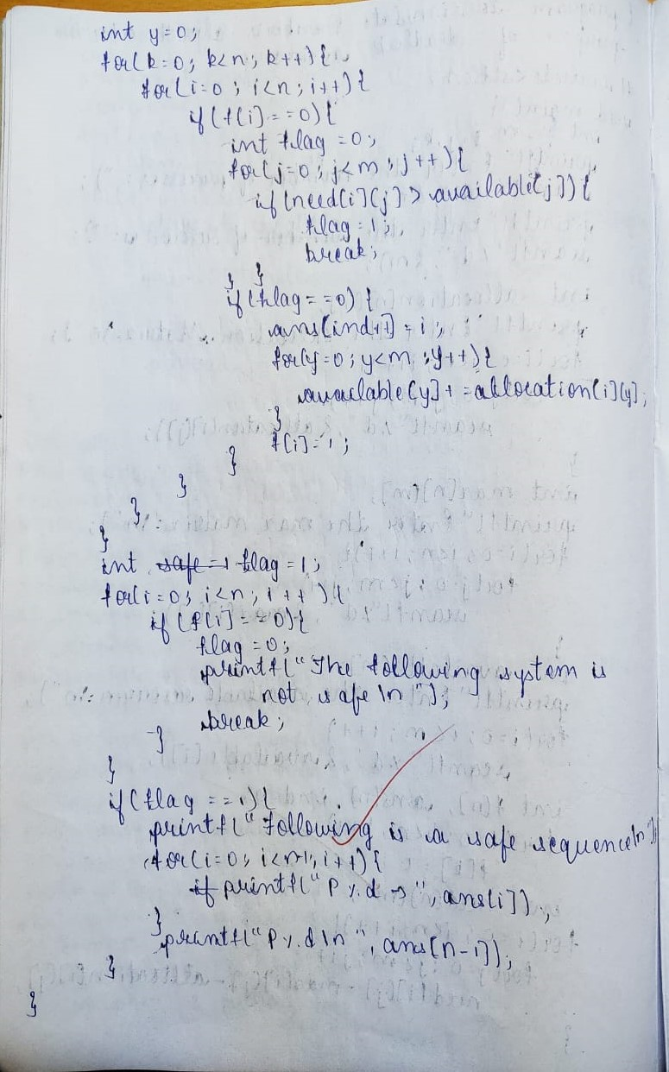

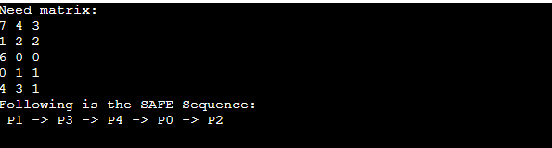

**Program 8**

**Write a C program to simulate deadlock detection**

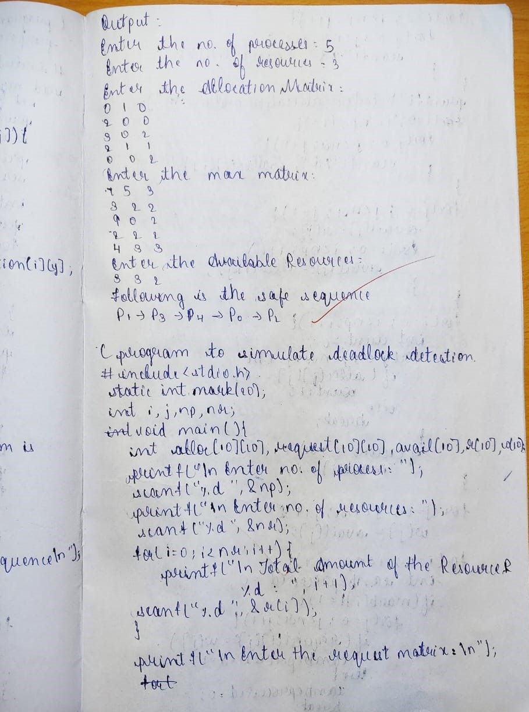

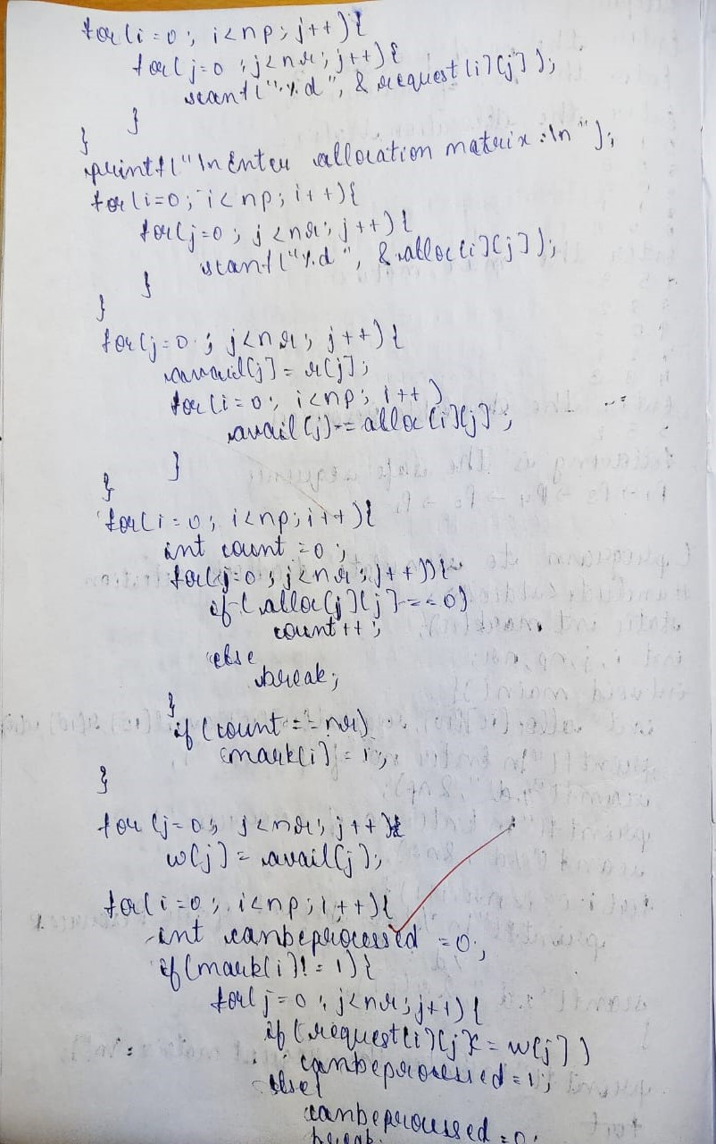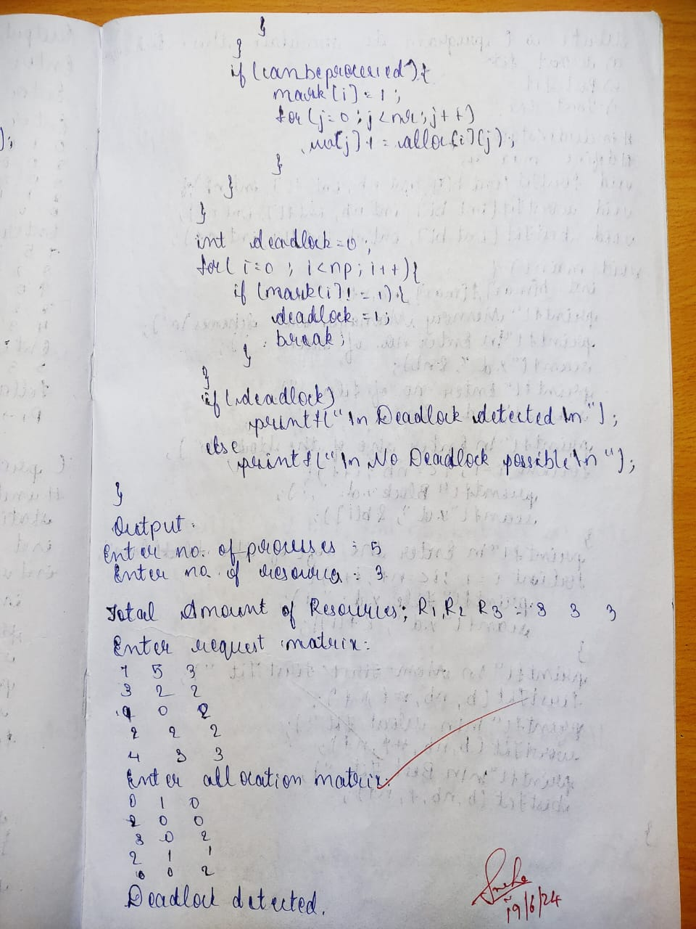

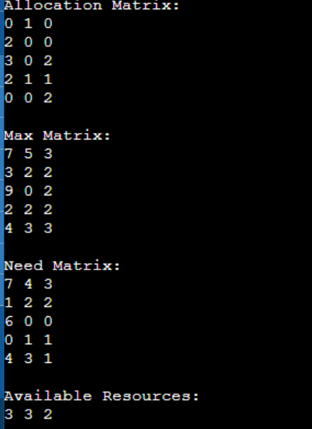

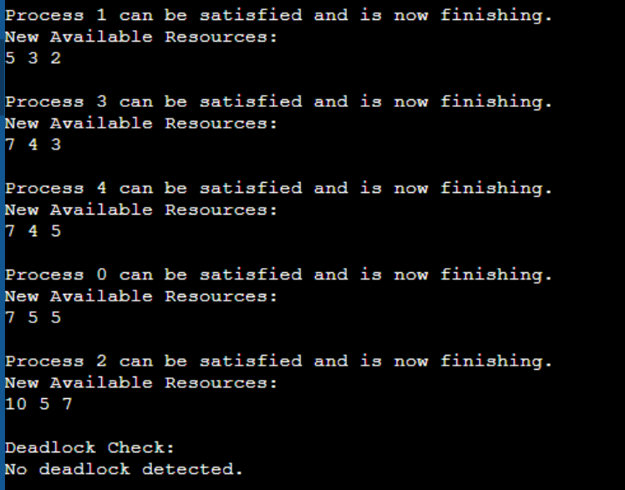

**Program 9**

**Write a C program to simulate the following contiguous memory allocation techniques**

**a) Worst-fit**

**b) Best-fit**

**c) First-fit**

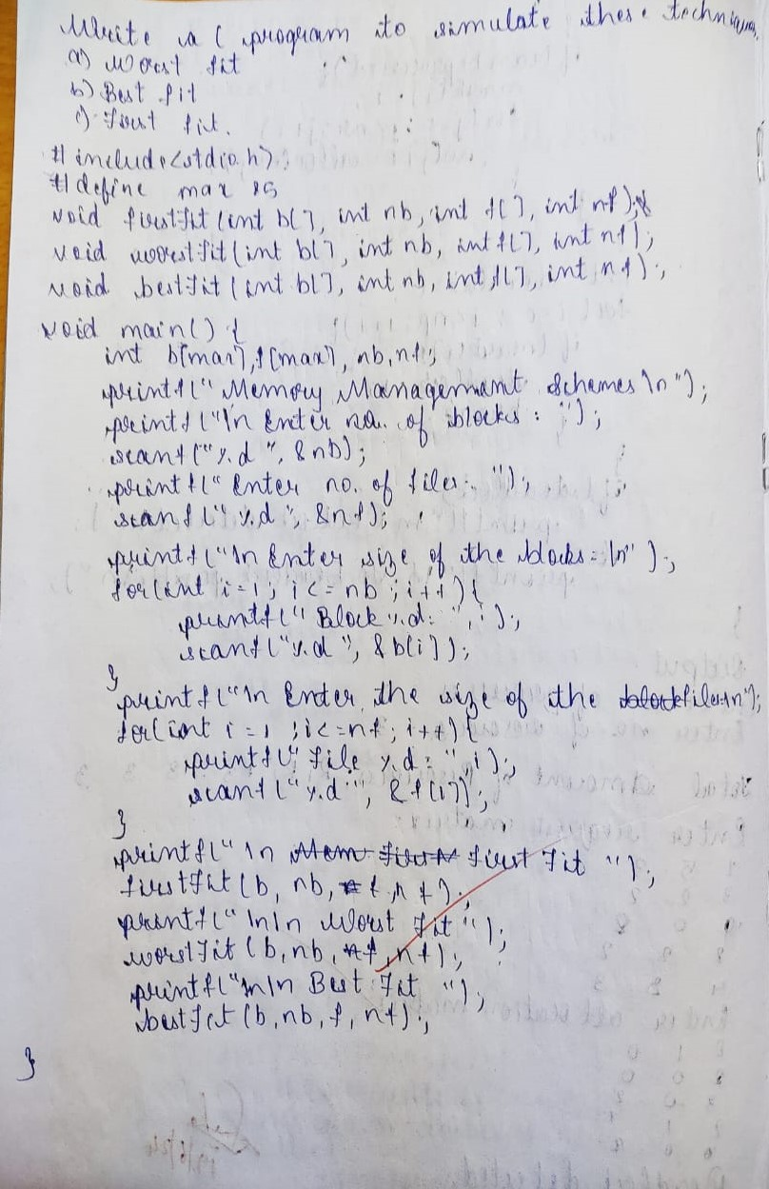

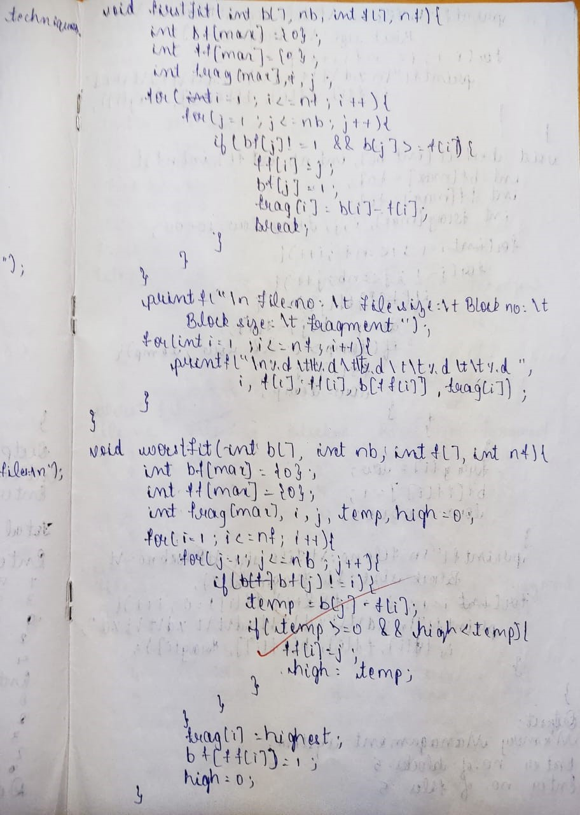

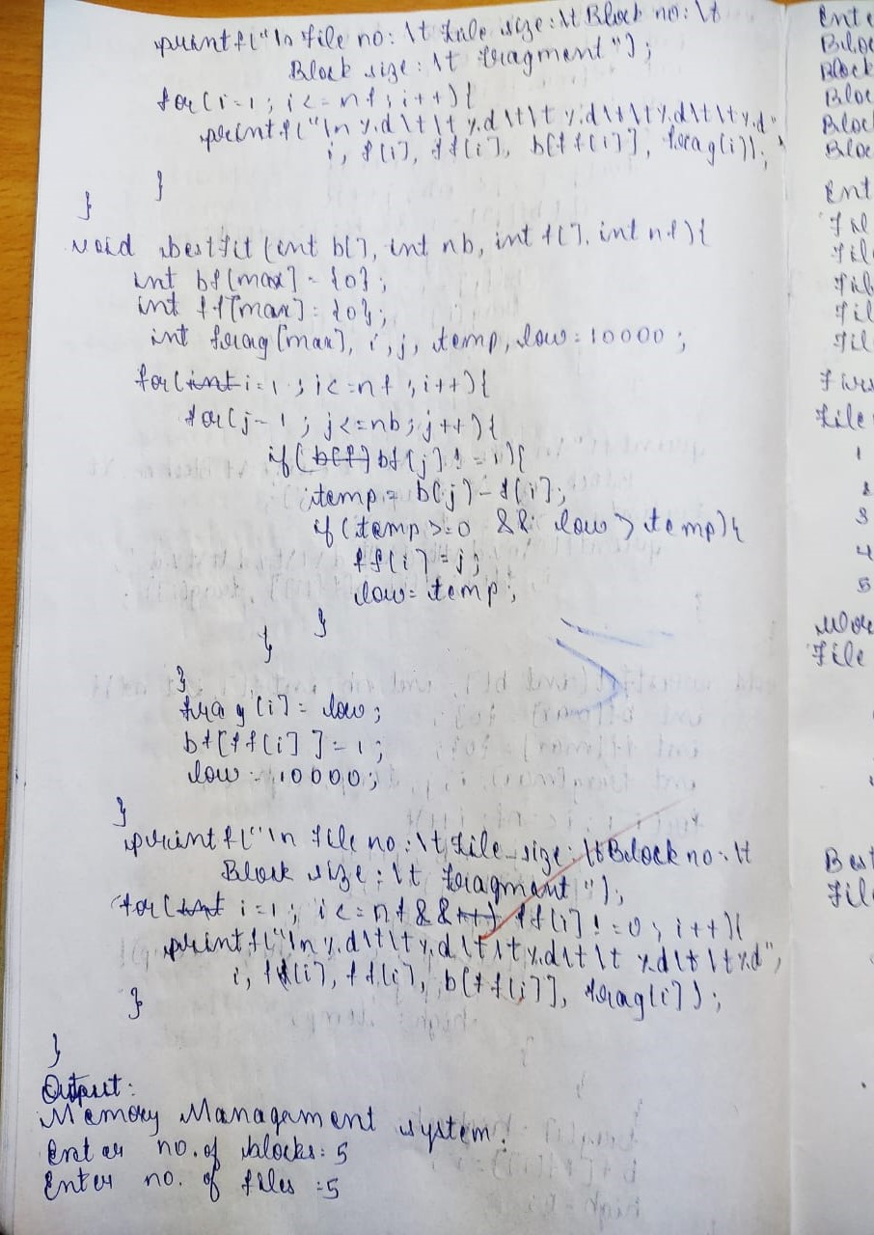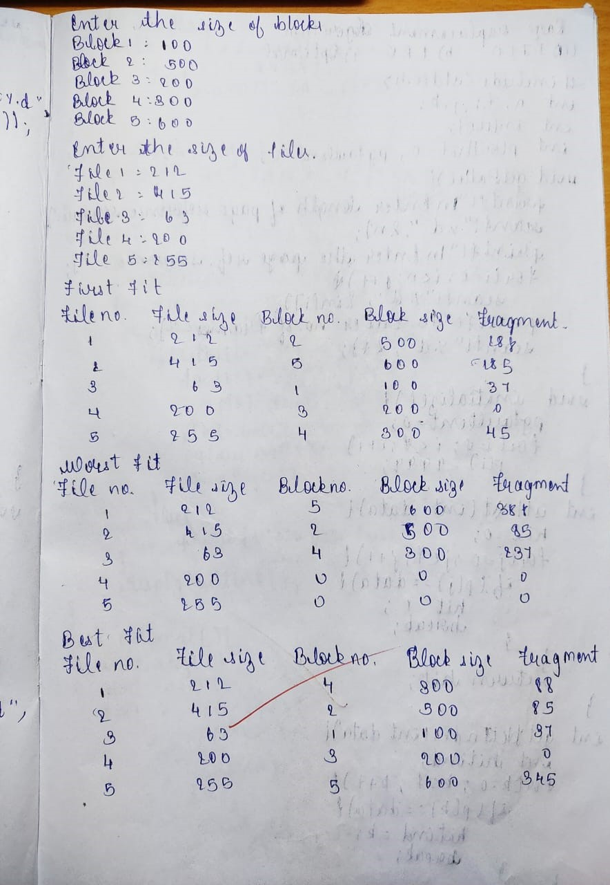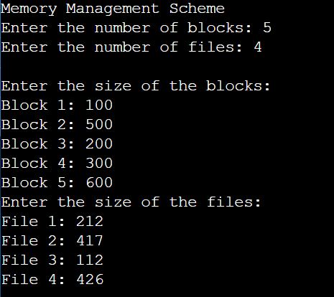

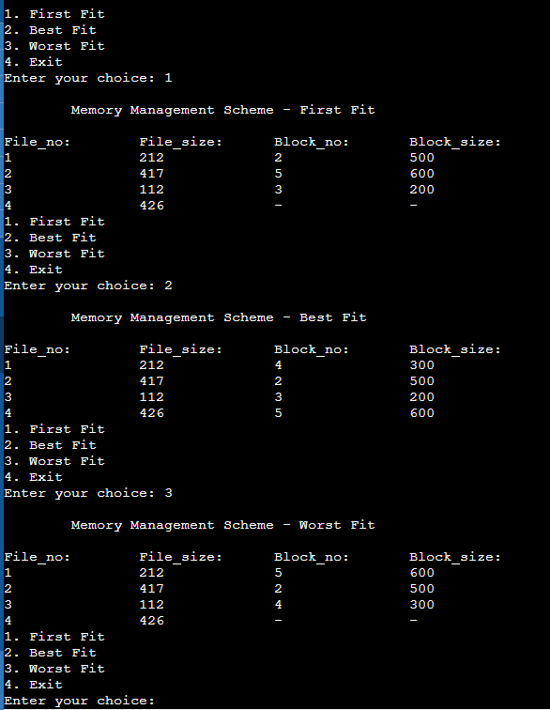

**Program 10**

**Write a C program to simulate page replacement algorithms**

**a) FIFO**

**b) LRU**

**c) Optimal**

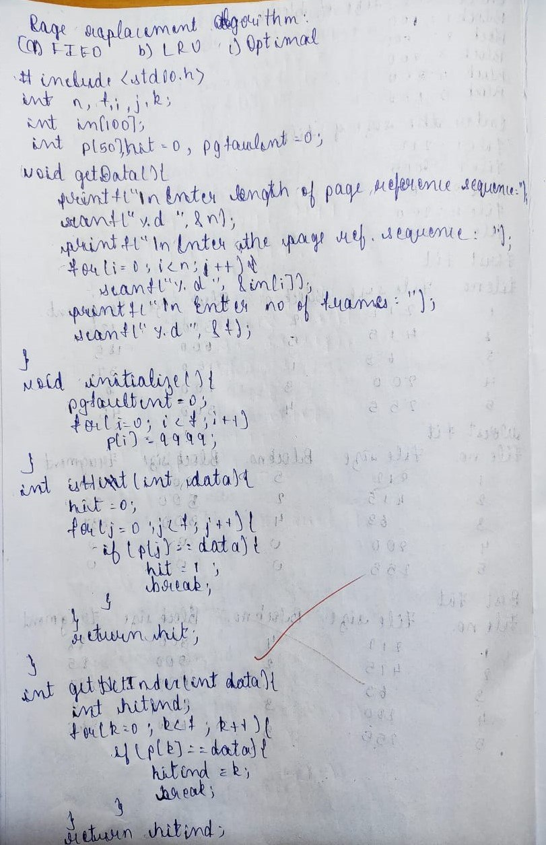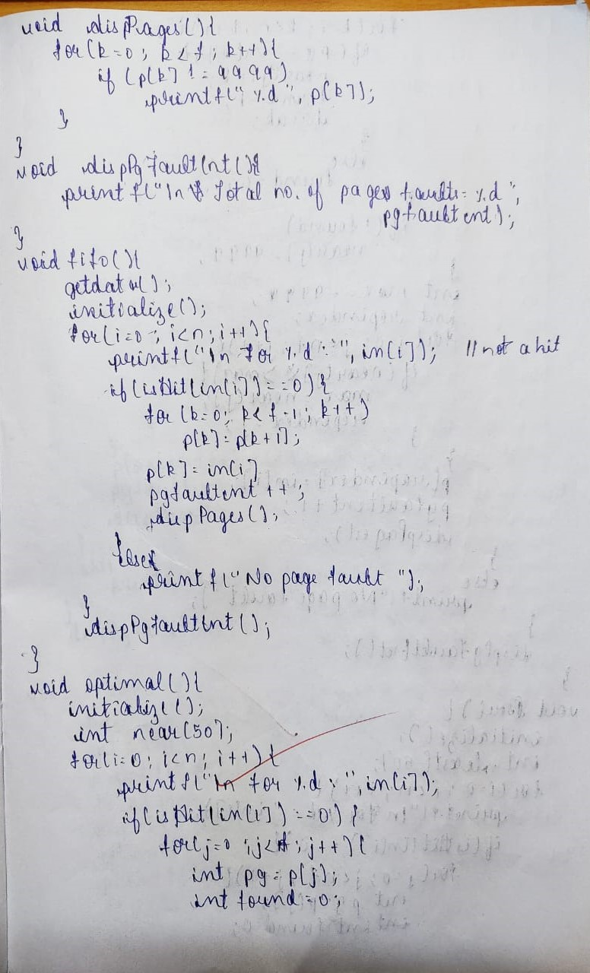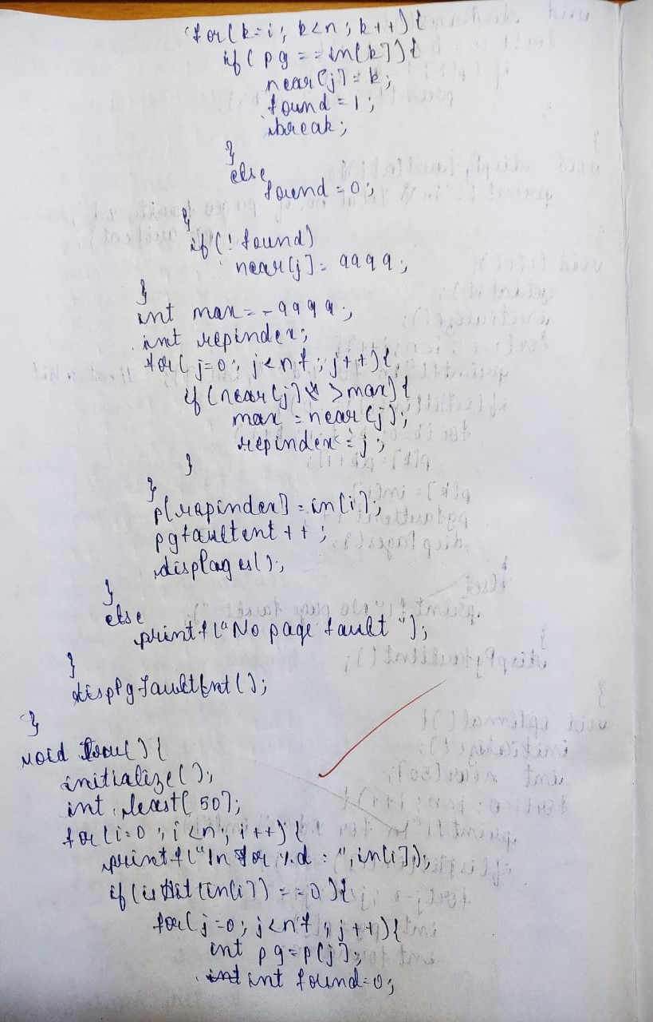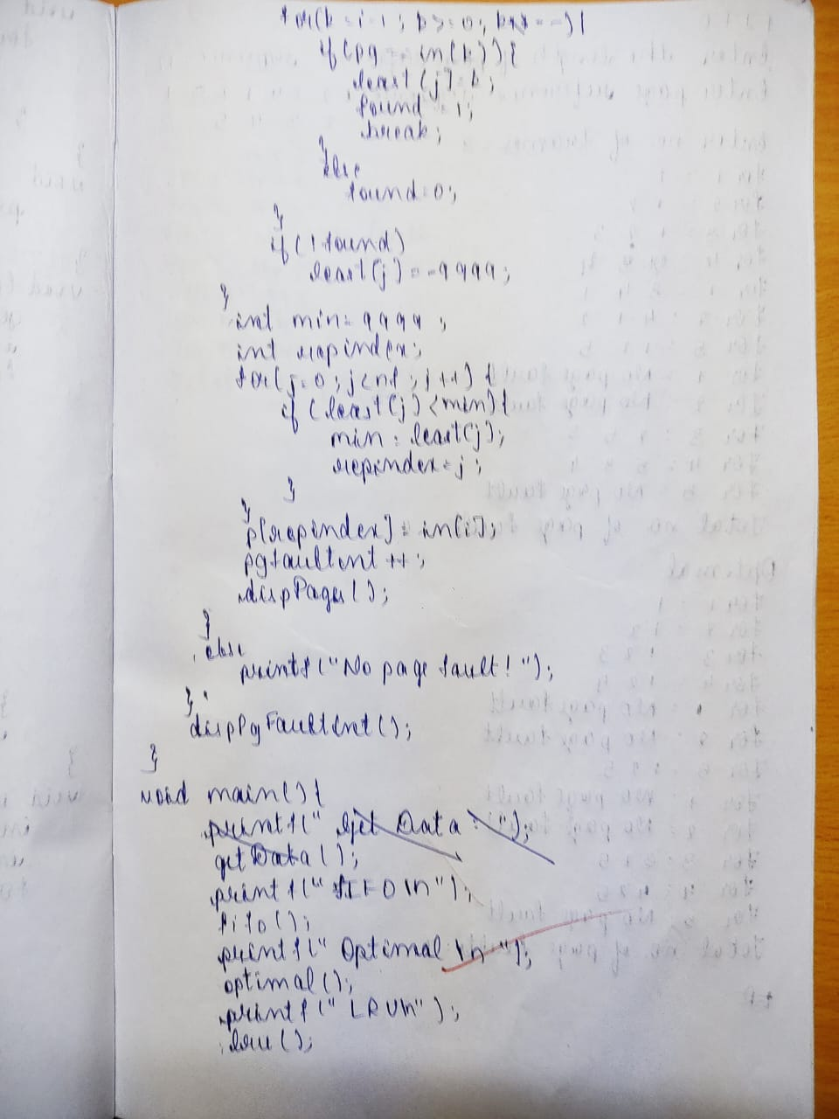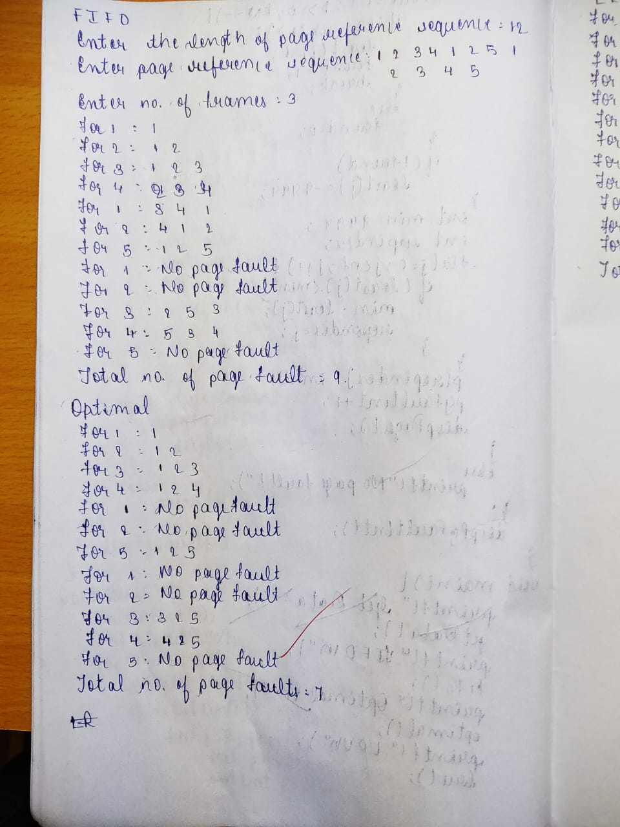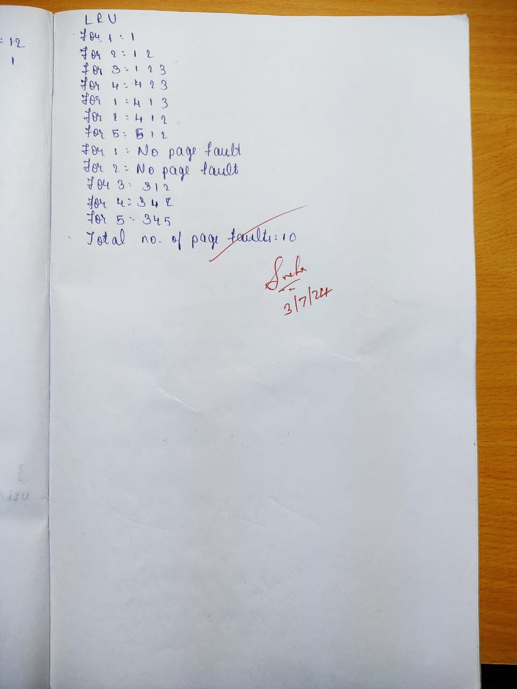

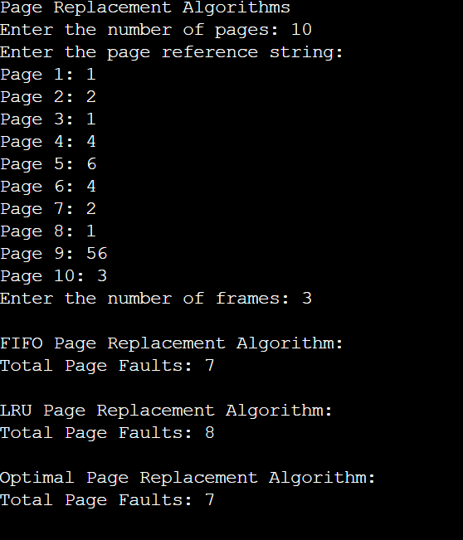

**Write a C program to simulate disk scheduling algorithms:**

**(a) FCFS**

**(b) SCAN**

**(c) c-SCAN**

(a) FCFS:

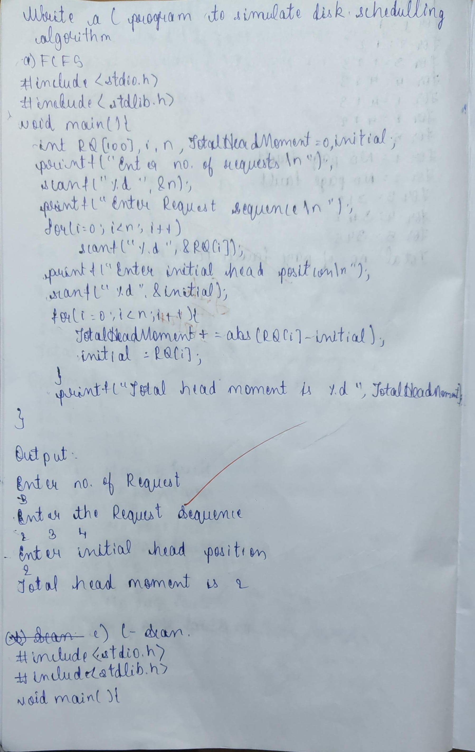

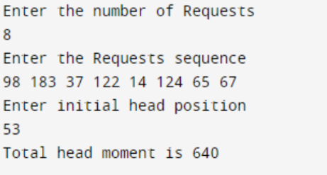

(b) SCAN:

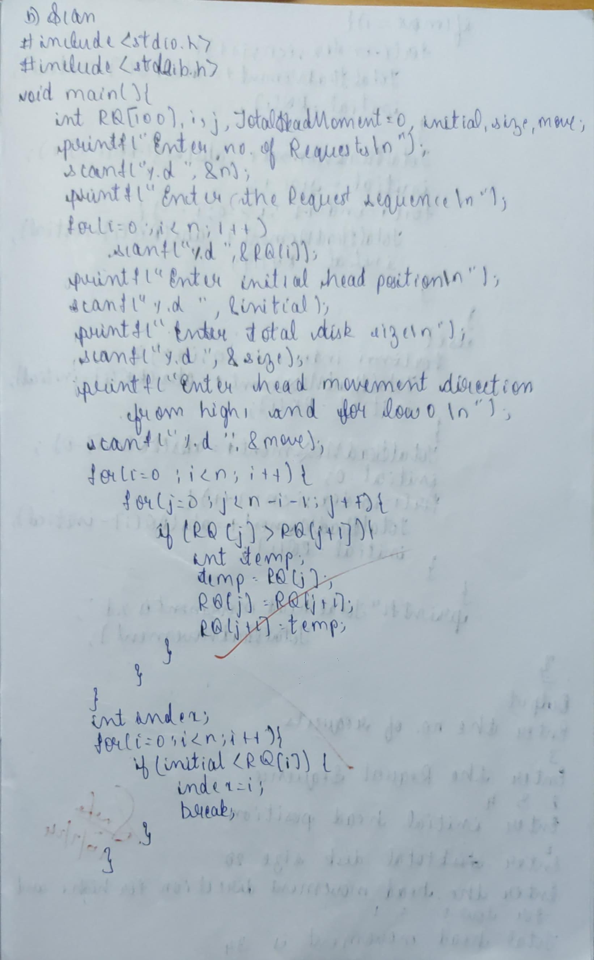

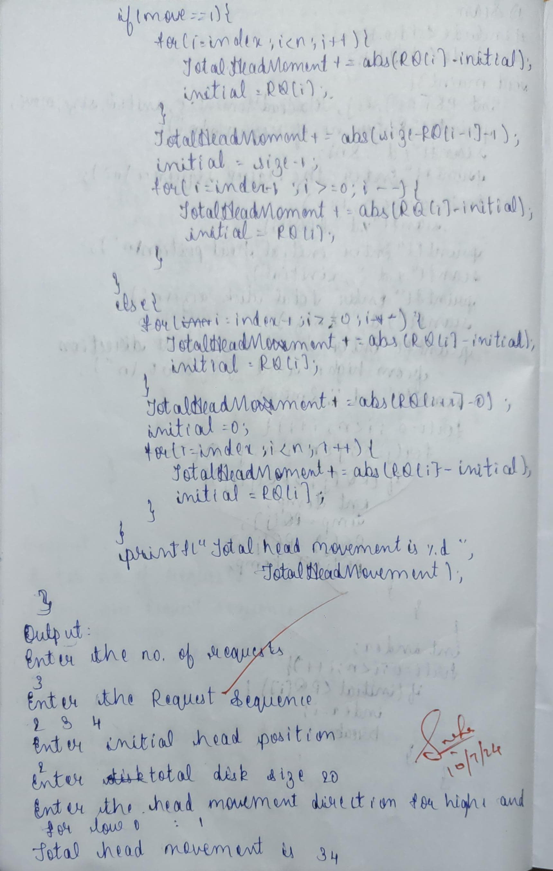

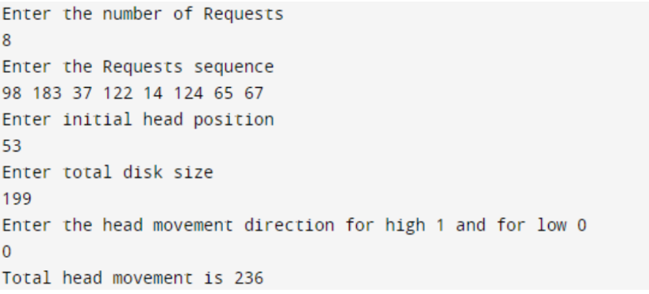

(c) c-SCAN:

